**Docker Commands from Lab 1.1**

**Project Scenario:**

1. Make Dockerfile
2. Build Image
3. Create container
4. Login on docker hub & puss my image to docker hub
5. Pull my image back from docker hub

**Practical Work:**

check my directories   
**$ ls**  
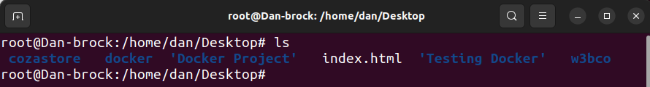  
goto cozastore directory

**$ cd cozastore**

Create dockerfile & check the file list

**$ touch Dockerfile**

**$ls**

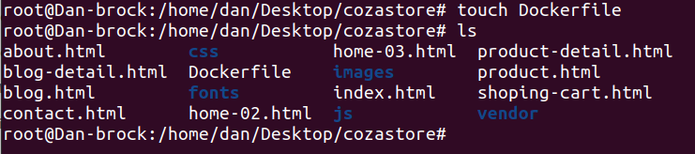

Now open dockerfile to give him instructions

**$ open Dockerfile**

**FROM nginx:latest**

**COPY . /usr/share/nginx/html**

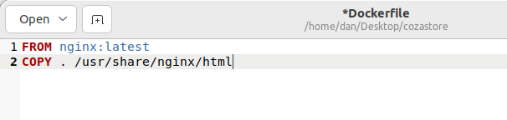

Build docker image from Dockerfile

**$ docker build –t web4docker:latest .**

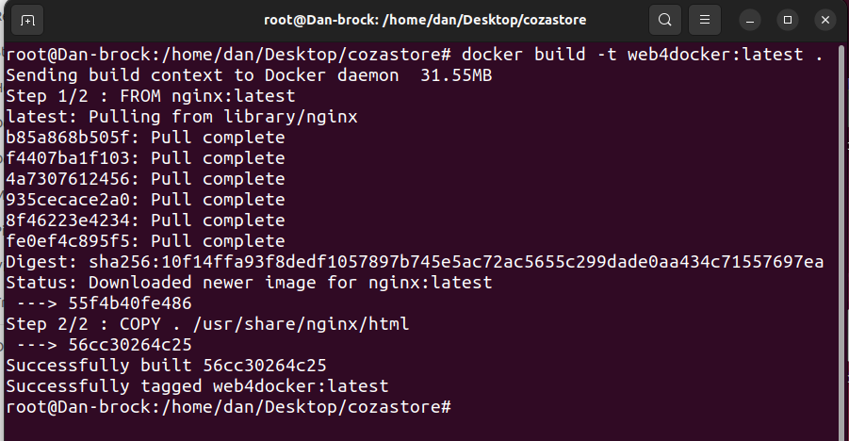

Check my image list to confirm my image is created or not

**$ docker images**

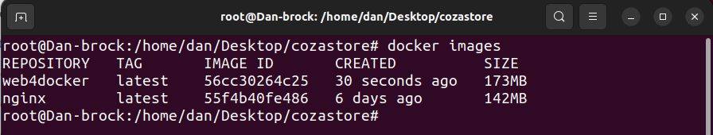

Make a container of my image

**$ docker run –d –name webcontainer –p 8080:80 web4docker:latest**



Check my container list to confirm my container is created or not

**$ docker ps**

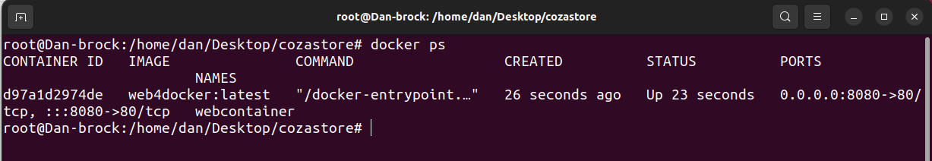

Now login to dockerhub to push my image on the docker hub

**$ docker login**

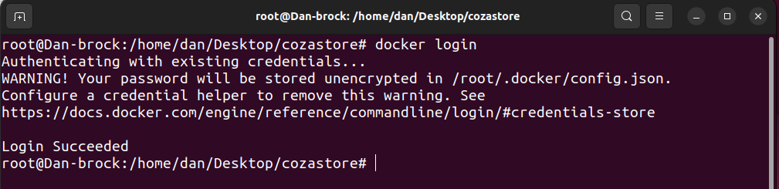

Now tag my image with my username

**$ docker tag web4docker:latest danbrock007/webiso**

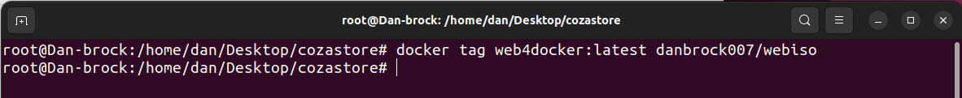

Now push my image on dockerhub

**$ docker push danbrock007/webiso**

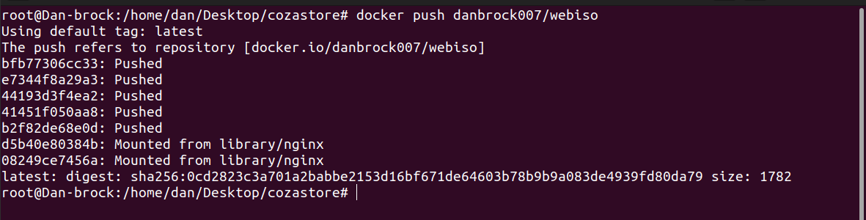

**After this complete I’ll check my image on docker hub**

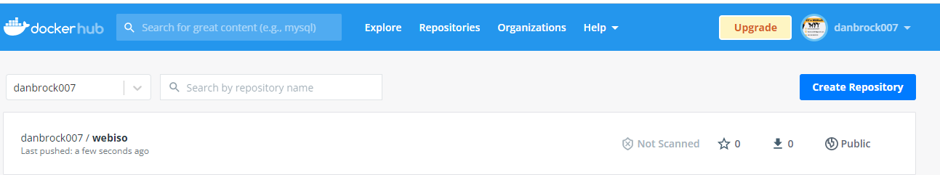

Now pull my image from docke hub

**$ docker pull danbrock007/webiso**

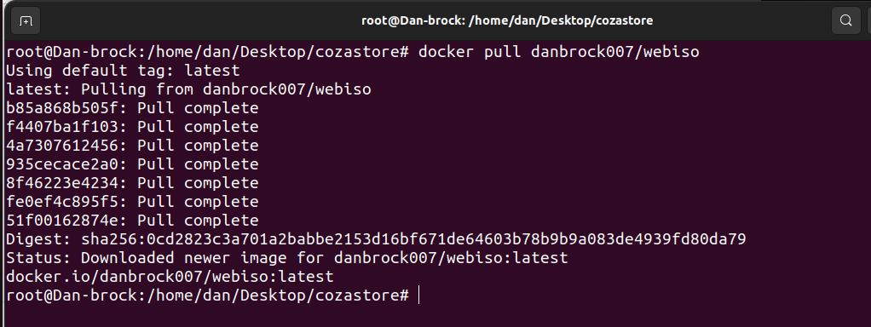

Let’s check docker images list to confirm my image is pulled or not

**$ docker images**

